Black-eyed Susan (Rudbeckia hirta)

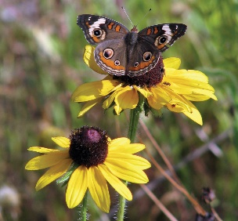

A bright, cheerful wildflower found throughout Florida in sandhills, flatwoods and disturbed areas. It is an excellent nectar source for a variety of butterflies and bees and is also a larval host to some moths. The seeds are eaten by birds.

Easy to grow and tough as nails, black-eyed Susan is a sunny-colored wildflower, is salt- and drought-tolerant, making it an excellent choice for coastal landscapes.

One of the nine *Rudbeckia* species native to Florida, black-eyed Susan is the most commonly grown of the species in landscapes and is perfect for butterfly gardens.

The plant forms a mound of foliage topped with a bright display of flowers characterized by brown centers surrounded by red, orange, yellow, or golden petals.

Black-eyed Susan seeds can be planted directly in the garden, or you can buy small plants. Choose a sunny, well-drained location in the spring. The flowers will develop ten to fourteen weeks after the seed is planted and should persist throughout the summer while other plants wilt.

Deadhead, or remove, faded blossoms to prompt more profuse blooming. Black-eyed Susans also make great cut flowers.

**Family**: Asteraceae (Aster or Composite family)  
**Native range**: Nearly throughout Florida  
**Hardiness**: 8A–11  
**Soil**: Rich, well-drained soils  
**Exposure**: Full sun to minimal shade  
**Growth habit**: 1–3’ tall with 1–2’ spread  
**Propagation**: Seeds  
**Garden tips**: Black-eyed Susans are easy to grow and maintain. They spread by way of abundant self-sown seed. They are adaptable to both dry and moist sites, but flower best with regular moisture. Depending on the conditions, they can perform as a short-lived perennial, biennial or annual. Black-eyed Susan is excellent for mixed wildflower gardens, and disturbed areas such as roadsides and medians.

**Note**: There are two forms of Rudbeckia hirta found naturally in Florida — R. hirta var. angustifolia in the northern third of the state, and R. hirta var. floridana in the central and southern part of Florida. Both forms are typically available from native nurseries and they usually sell the form most common to their latitude; however, when purchasing R. hirta for your landscape, be sure to ask which variety is being sold. Non-native varieties are not recommended.